**Development of a Website for the Department of Computer Science & Engineering of Jahangirnagar University**

A Project Report Submitted to the Department of Computer Science and Engineering, Jahangirnagar University in Partial Fulfillment of the Requirements for the Degree of Master of Science (MSc) in Computer Science and Engineering Under PMSCS Program.

**Submitted By**

**S. Sadrul Hossain**

**Id:** CSE201702113

**Batch:** 14th

**Supervised By**

**Professor Dr. Md. Imdadul Islam**

Chairman

Department of Computer Science & Engineering

Jahangirnagar University



**Pmscs program**

**department of computer science & engineering**

**Jahangirnagar UNIVERSITY**

**savar, Dhaka-1342, BANGLADESH**

**summer 2018**

**DECLARATION**

I do, hereby declare that the work presented in this project report is done by us under the Supervisor of **Professor Dr. Md. Imdadul Islam**,Chairman of Computer Science and Engineering Department, Jahangirnagar University, Savar, Dhaka. We also declare that neither this project nor any part thereof has been submitted elsewhere for the award of any degree or diploma.

# Submitted by:

**Name: S. Sadrul Hossain**

**ID: CSE201702113**

**Batch: 14th**

Department of Computer Science and Engineering

Jahangirnagar University,

Savar, Dhaka, Bangladesh.

# APPROVAL AND ACCEPTANCE

This project report written by **S. Sadrul Hossain** (ID:CSE201702113) entitled “**Development of a Website for the Department of Computer Science & Engineering of Jahangirnagar University**” is submitted to the PMSCS Program, Department of Computer Science and Engineering, Jahangirnagar University in partial fulfilment of the requirements for the degree of master of Science in Computer Science. The project is done under the supervision of **Professor Dr. Md. Imdadul Islam**, Chairman of Computer Science and Engineering Department, Jahangirnagar University.

We have examined this report and recommend its acceptance

**Professor Dr. Md. Imdadul Islam**

Chairman, Supervisor and 1st Examiner

Department of Computer Science and Engineering

Jahangirnagar University

Savar, Dhaka, Bangladesh

**Professor Dr. Jugal Krisna Das**

2nd Examiner

Department of Computer Science and Engineering

Jahangirnagar University

**Accepted By**

**-------------------------------------**

**Professor Dr. Abul Kalam Azad**

Coordinator,

PMSCS program 2018

Department of Computer Science and Engineering

Jahangirnagar University

Savar, Dhaka, Bangladesh

Savar, Dhaka, Bangladesh

**ACKNOWLEDGEMENT**

First I express our heartiest thanks and gratefulness to almighty Allah for his divine blessing makes us possible to complete this project successfully.

I feel grateful to and wish my profound indebtedness to **Professor Dr. Md. Imdadul Islam, Chairman**, Department of CSE, Jahangirnagar University, Savar, Dhaka. Deep knowledge and keen interest of my supervisor in the field of Web Development influenced me to carry out this project. His endless patience, scholarly guidance, continual encouragement, constant and energetic supervision, constructive criticism, valuable advice, reading many inferior draft and correcting them at all stage have made it possible to complete this project.

I would like to thank all of my batch mates in Jahangirnagar University, who took part while completing the course work.

Finally, I must acknowledge with due respect the constant support and patience of my parents.

**ABSTRACT**

In the modern era of science and technology, one of the most important thing for any institution or organization is having a website of that particular institution or organization. This enables that institution or organization to share information about their organization and branding their organization name. Besides, a lot of web-based system can be connected to that web domain that helps in conducting many functions regarding daily activities of that particular institution or organization.

This project is all about the development of a website for CSE department of Jahangirnagar University. In this project, there are some required modules given that is to be developed. The home page connects all pages with the links shown in the menu bar and the message of the honorable chairman of CSE department is also shown. There are pages for teachers and staffs list with detailed information of individual teachers. There are also pages regarding course and journal lists. Also, there are lists of notice, important events and news.

To develop this website, Laravel framework is used where HTML is used for web page building and PHP is used development. CSS is used for innovative design with Bootstrap. HTML, CSS, JavaScript, PHP is vastly used for web development purpose. Bootstrap helps with built-in design style classes where only thing need to do is to declare the class name. Laravel framework makes it easy to work with PHP and to create well-arranged, easy to understand and clean blocks of code. It maintains security of the app and also provides with good loading speed.

This project, if successfully completed, can be used for the department of computer science and engineering of Jahanginagar University for information sharing and branding of CSE department.

**TABLE OF CONTENTS**

|  |  |
| --- | --- |
| **CONTENTS** | **PAGES** |
| Declaration | ii |
| Approval and Acceptance | iii |
| Acknowledgement | iv |
| Abstract | v |
|  |  |
| **LIST OF FIGURES** | **viii** |
|  |  |
| **CHAPTER** |  |
| **CHAPTER 1: INTRODUCTION** | **1-7** |
| 1.1 Introduction to The New System | 1 |
| 1.2 Objective | 2 |
| 1.3 Scope | 3 |
| 1.4 Methodology | 3 |
| 1.5 Problem Identification of Current Process | 3 |
| 1.6 Feasibility of The New System | 4 |
| 1.7 Organization of the Document | 6 |
|  |  |
| **CHAPTER 2: DESIGN PROCEDURE** | **8-21** |
| 2.1 Analysis of User View of The System | 8 |
| 2.2 Requirements for Development and Implementation | 9 |
| 2.3 Design Procedure of the System | 12 |
| 2.4 Database Design | 14 |
| 2.5 User Interface Design | 15 |
|  |  |
| **CHAPTER 3: IMPLEMENTATION** | **22-24** |
| 3.1 Controller | 22 |
| 3.2 Model | 24 |
| 3.3 Route | 24 |
|  |  |
| **CHAPTER 4: TESTING & RESULT** | **25-28** |
| 4.1 Testing of The System | 25 |
| 4.2 Unit Testing | 25 |
| 4.3 Integration Testing | 26 |
| 4.4 System Testing | 27 |
|  |  |
| **CHAPTER 5: CONCLUSION** | **29** |
| 5.1 Discussion | 29 |
| 5.2 Limitation | 29 |
| 5.3 Future Scope | 29 |
|  |  |
| **REFERENCES** | **30** |

**LIST OF FIGURES**

|  |  |
| --- | --- |
| **FIGURES** | **PAGE NO** |
| Figure 1.1: System Development Lifecycle (SDLC) | 2 |
| Figure 2.1: Project design procedure in Laravel | 13 |
| Figure 2.2: database design | 14 |
| Figure 2.3: Homepage | 15 |
| Figure 2.4: Message of chairman | 16 |
| Figure 2.5: List of faculty members | 17 |
| Figure 2.6: Admin panel | 18 |
| Figure 2.7: Add course page | 18 |
| Figure 2.8: Edit course page | 19 |
| Figure 2.9: Show course list page | 19 |
| Figure 2.10: Add teacher page | 20 |
| Figure 2.11: Edit teacher page | 20 |
| Figure 2.12: Show teacher list page | 21 |
| Figure 4.1: Result of a unit test | 26 |
| Figure 4.2: Result of an integrated test | 27 |

**CHAPTER: 1**

**INTRODUCTION**

* 1. INTRODUCTION TO THE NEW SYSTEM

Development of a website for department of computer science & engineering of Jahangirnagar University is the project to build a website of CSE department with rich content and information. This website can be used by all students of CSE department while there will be a few administrator among teachers and staff users with authorization.

System Development Life Cycle (SDLC) is the overall process of developing information systems through multi-user process from feasibility study, investigation of requirements through analysis, design, implementation, testing and maintenance. In this system development life cycle system analysis and design of the proposed system are the key concern. Software is a group of program that can automate a system. Software may automate a system fully or it may automate a part of a system. Therefore software and system development are very much related to each other [2].

Software development is a complicated process. It requires careful planning and execution to meet the goals. Sometimes a development must react quickly and aggressively to meet ever changing market demands. Maintaining Software quality hinders fats paced software development, as many testing cycle are necessary to ensure quality products. There are many stage of software development. A commercial software product is usually provide for marketing demands. Sales and marketing people have firsthand knowledge of their customer`s requirement. Based upon these market requirements, scenario software creates architecture for the products along with the function and design specifications. Then the development process starts. After the initial development phase, software testing begins and many times it done in parallel with the development process. Documentation is also part of the software development a product cannot be brought to market without manuals. Once the development and testing are done, the software is release and the supports cycle begins. This phase may including bug fixed and new releases [3].

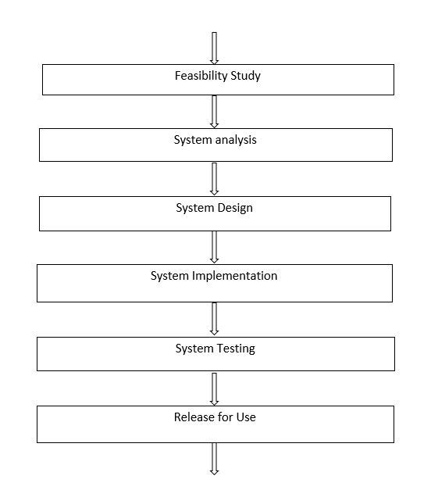

**Figure 1.1: System Development Lifecycle (SDLC)**

* 1. OBJECTIVE

The main objective of this project is to develop a website for our department. Also I want to apply our programming skill, knowledge and creative idea into some area.

Day by day all the systems are going to be automated. Internet has become an integral part of our life. A website is a platform for any organization for information sharing and binding all other important web-based systems in one domain. So by doing this project we can create that platform for our department..

* 1. SCOPE

This software is comprised of a relational database, software to act on that database, and one graphical interfaces. It uses separate software function discrete Programs called modules, which are then integrated into a unified interface. Examples of modules include: acquisitions (addition, deletion, edition of teacher information; addition, deletion, edition of staff information; addition, deletion, edition of course, journal and publishing notices, events and news).

* 1. METHODOLY
* This project is for the department of computer science & engineering
* The methods are learnt in which the processes are performed manually
* All necessary requirements are collected.
* Algorithms are developed according to these methods
* Those algorithms are applied in PHP.
* The main goal was to build a website with
  1. PROBLEM IDENTIFICATION OF CURRENT PROCESS

There are a lot of problems in present website of CSE department.

* The first problem is its contents are no very rich.
* The website does not contain much information.
* Teachers’ information is not detailed.
* No course list is given in the website.

* 1. FEASIBILITY OF THE NEW SYSTEM

A systems request must pass several tests, called a feasibility study, to see whether it is worthwhile to proceed further. Sometimes a feasibility study is quite simple and can be done in a few hours. If the request involves a new system or a major change, however, extensive fact-finding and investigation is required [4]. A well-designed feasibility study should provide a historical background of the business or project, a description of the product or service, accounting statements, details of the operations and management, marketing research and policies, financial data, legal requirements and tax obligations [5].

TECHNICAL FEASIBILITY

This assessment is based on an outline design of system requirements, to determine whether the company has the technical expertise to handle completion of the project. When writing a feasibility report, the following should be taken to consideration:

* A brief description of the business to assess more possible factors which could affect the study
* The part of the business being examined
* The human and economic factor
* The possible solutions to the problem
* At this level, the concern is whether the proposal is both technically and legally feasible (assuming moderate cost).

The technical feasibility assessment is focused on gaining an understanding of the present technical resources of the organization and their applicability to the expected needs of the proposed system. It is an evaluation of the hardware and software and how it meets the need of the proposed system [6].

To fulfill the requirements of this project, we need to have knowledge in web related areas. As we have knowledge in PHP, HTML, CSS, JavaScript and JQuery, we were quite hopeful to fulfill all the requirements of the system.

OPERATIONAL FEASIBILITY

Operational feasibility is a measure of how well a proposed system solves the problems, and takes advantage of the opportunities identified during scope definition and how it satisfies the requirements identified in the requirements analysis phase of system development [4].

The operational feasibility assessment focuses on the degree to which the proposed development projects fits in with the existing business environment and objectives with regard to development schedule, delivery date, corporate culture and existing business processes.

To ensure success, desired operational outcomes must be imparted during design and development. These include such design-dependent parameters such as reliability, maintainability, supportability, usability, productivity, disposability, sustainability, affordability and others. These parameters are required to be considered at the early stages of design if desired operational behaviors are to be realized. A system design and development requires appropriate and timely application of engineering and management efforts to meet the previously mentioned parameters. A system may serve its intended purpose most effectively when its technical and operating characteristics are engineered into the design. Therefore, operational feasibility is a critical aspect of systems engineering that needs to be an integral part of the early design phases [7].

As we know how the processes are performed manually, we designed the system to perform the processes in the same manner automatically.

ECONOMIC FEASIBILITY

Economic feasibility means that the projected benefits of the proposed system outweigh the estimated costs usually considered the total cost of ownership (TCO), which includes ongoing support and maintenance costs, as well as acquisition costs. To determine TCO, the analyst must estimate costs in each of the following areas:

* + - People, including IT staff and users
    - Hardware and equipment
    - Software, including in-house development as well as purchases from vendors
    - Formal and informal training
    - Licenses and fees
    - Consulting expenses
    - Facility costs
    - The estimated cost of not developing the system or postponing the project.

In addition to costs, we need to assess tangible and intangible benefits to the company. The systems review committee will use those figures, along with our cost estimates, to decide whether to pursue the project beyond the preliminary investigation phase [4].

* 1. ORGANIZATION OF THE DOCUMENT

The chapters in this report are organized in the following manners:

* Chapter 2 deals with the design procedure of the website. All type of users are determined in this chapter. All software and hardware requirements are stated. All template design and database design are covered in this chapter which includes the database design, entity relationship and data flow in the system.
* In chapter 3, implementation of the system is shown with several parts of algorithm.
* In chapter 4, it is covered with the analysis of quality of the system through testing.
* In chapter 5, the document is concluded.

**CHAPTER: 2**

**DESIGN PROCEDURE**

2.1 ANALYSIS OF USER VIEW OF THE SYSTEM

System analysis is a detailed study of the various operation performed by the system and their relationship within the system and its outside environment. A key question may come that what must be done to solve the problem? Defining boundaries of the system and determining whether or not a candidate system should consider other related system. During analysis, data are collected on the available files, decision points and transaction handled by the present system.

This Chapter also provide a brief discussion of scope and objective of the proposed system and requirement analysis. A brief overview of technology those have been used for the implementation of the system also include in this chapter

There are three types of users of the website and their views to the system will be different from their one context.

SUPER USER

The Knowledge worker, namely analysts and programmers, who will meet the management level user needs by designing the database and writing program to extract reports out of the system.

ADMINISTRATOR

The Administrator is the ultimate user of the system. Admin should login to the system to operate. None other than the admin can access to the system who has no login access. A teacher from each department is selected as admin in the system.

STAFF USER

This level of user can only access where authorization is not necessary. This user can only see the report generated by the system.

2.2 REQUIREMENT FOR DEVELOPMENT AND IMPLEMENTATION

To run this software smoothly in practical life we must fulfill some requirements. The requirements are:

1. Hardware requirement
2. Software requirement

HARDWARE REQUIREMENT

One database server must be available to implement the system with following configuration.

|  |  |
| --- | --- |
| Number of PC | 1 server class brand PC hosting MySQL database server |
| Processor Specification | Pentium IV Speed 1.2 GHz or above |
| Memory Specification | 1GB |
| Hard Disk Specification | 100GB |
| Operating System | Windows 7 or above |

SOFTWARE REQUIREMENT

1. Windows 7 or above
2. Wamp server or xampp server[PHP, APACHE, MySQL]
3. Notepad ++ , Netbeans etc

SERVER

Almost all of the work web application takes place on the server. A specific application, called a web server, will be responsible for communicating with the browser. A relational database server stores whatever information the application requires. Finally, we need a language to broker requests between the web server and database server, it will also be used to perform programmatic tasks on the information that comes to and from the web server. But of course none of this is possible without an operating system. The web server, programming language, and database server we use must work well with the operating system.

There are many web servers out there in the market. To implement exam automation system, APACHE is used, because the apache web server is the most popular web server. PHP will most often run as an apache extension, known as apache module. It is a great web server, and it is extremely fast and amazingly stable.

MYSQL has been used as database in the proposed system. It is cost-effective. It is quick and powerful. It may not have every bell and whistle available for a relational database, but for most users there is plenty.

WAMP or XAMPP server is combination of PHP, APACHE, and MYSQL server.

TEXT EDITOR

Text editor is important software to design and develop web pages. Text editor is the place where programs are written to be compiled. Version 3 of Sublime Text is used in the development of this website. Sublime text is a popular text editor. It has awesome themes and other features multiple cursors system. Emmet plugin is available for sublime text which helps to auto-fill HTML code.

SCRIPTING LANGUAGES

PHP has been used as scripting language as it is easy and fast. PHP has managed the perfect mix power, structure and easy to use. In the end, PHP offers the best opportunity to develop powerful web application quickly. The generalization made, there are other excellent reasons for choosing PHP.

* **Cross-platform:** Most PHP code can be processed without alteration on computers running many different operating systems. For example, a PHP script that runs on windows generally also runs well on Linux.
* **HTML-embedded:** PHP code can be written in files containing a mixture of PHP instructions and HTML code.
* **Server-side:** The PHP programs are run on a server, specifically a web server.
* **Web-scripting language:** PHP programs run via a web browser.

This means, programs that mix PHP code and HTML, run them on a web server, and access them from a web browser that displays the result of PHP processing by showing the HTML returned by run by the web server [8].

MVC FRAMEWORK

MVC is a system where all programs are divided into three essential categories, model, view and controller. View is the part where programs are created display the design to the users. Controller controls what is to be displayed, how is to be displayed and how much is to be displayed. Model is used to create relation between data which passes across the system. Frameworks can be used to manage MVC in the system.

Laravel is one of the most popular framework for PHP web development. Laravel is capable of handling big web project. Laravel ensures security of the site and creates quality code. This website is built in laravel framework.

2.3 DESIGN PROCEDURE OF THE WEBSITE

In this proposed project of “**Development of a Website for CSE Jahangirnagar University**”. The proposed modules that should be contained for the design are stated hereby.

1. A home page containing the message of chairman of CSE department.

2. Full list of faculty members of CSE department with detailed information.

3. Full syllabus of the undergraduate program of CSE department.

4. Important events.

5. Notice.

6. Full list of journals of CSE department.

7. PMSCS program.

To develop the website in MVC framework, we need to follow step by step procedures. The first thing to after analyzing all requirements is to create a laravel project inside htdocs folder of xampp. Then all necessary environment should be set such as creating good looking url and setting up database information in .env file.

Then next thing to do is to create database and model. Laravel makes it easy to create database inside the project with giving all necessary relationships, with just a few commands in command prompt.

Then HTML pages are being created to display the website in web browser. All programs are written in controllers created for each modules.

Finally, last thing to do is to creating route so that website can be accessible.

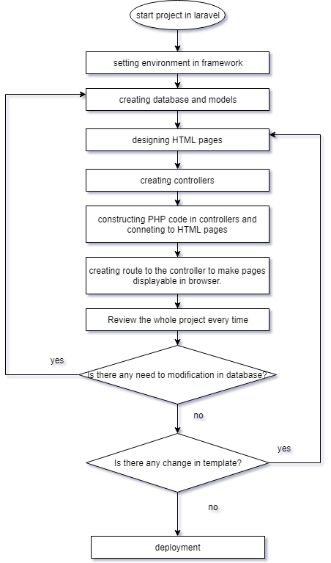

Figure 2.1: Project design procedure in Laravel.

2.4 DATABASE DESIGN

In laravel, database can be created easily using migration. Only thing to do is writing this command in command prompt,

php artisan make:model ‘model_name’ --m

Then model and migration will be created. In migrations, we can define all the columns of the tables with attributes.

$table->data_type(‘column_name’)->other_attributes();

Then to simply write these on command prompt,

php artisan migrate

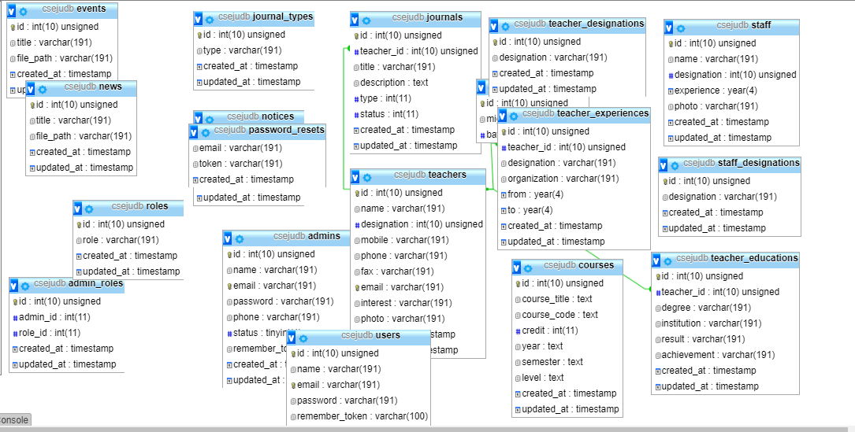

Figure 2.2: Database Design.

2.5 USER INTERFACE DESIGN

For MVC framework, view is the sector where all viewable graphical user interfaces are being designed. In this project, we have some proposed modules which is needed to be displayed in user interface.

HOME PAGE

The homepage contains Jahangirnagar University logo, menu bar, a photo of Jahangirnagar University CSE department and message of the chairman. This page also has sidebars with few notice and event list.

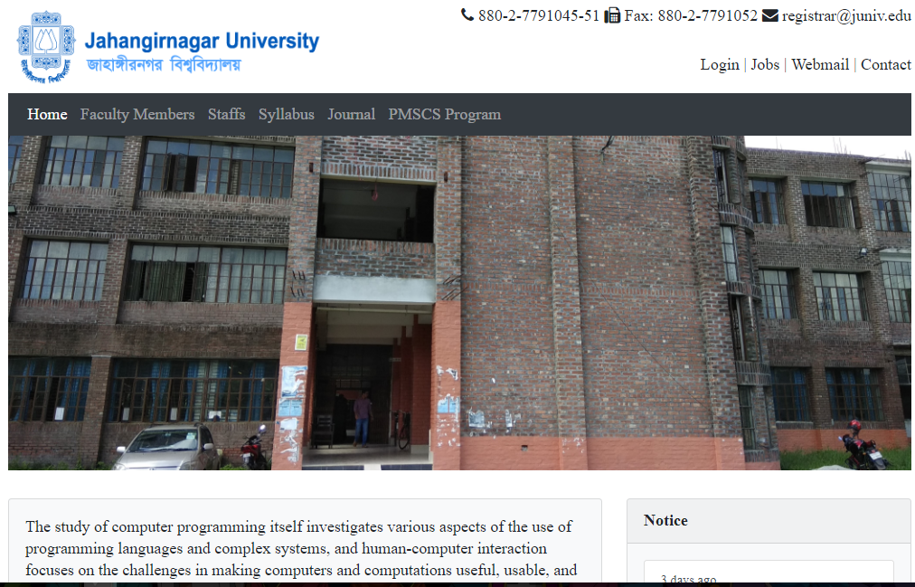

Figure 2.3: Home page of the website.

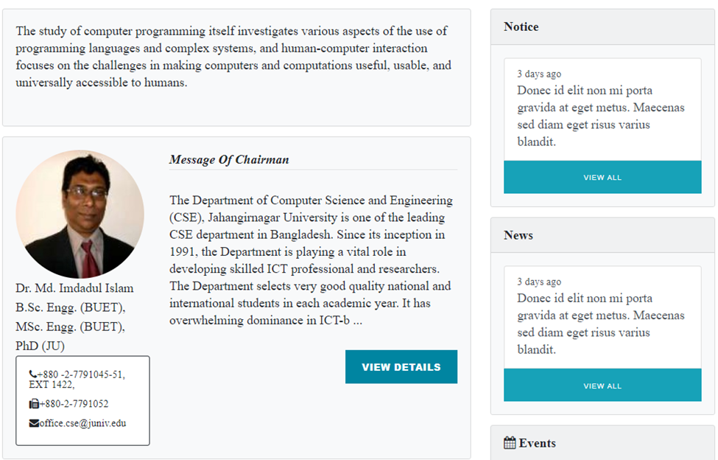

Figure 2.4: Message of chairman.

FACULTY MEMBER LIST

The next module was to displaying a faculty member list where the list of all teachers are shown in this page and by clicking on teachers;, users can get detailed information on the teachers.

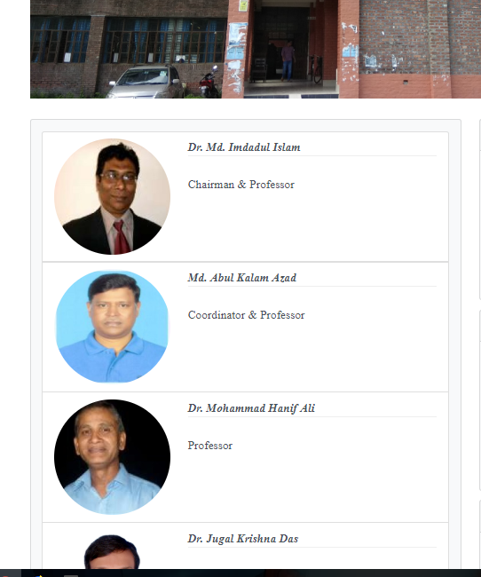

Figure 2.5: List of faculty members.

ADMIN PANEL

Admin panel is the main part of a website. It is needed to control what to show in the website. Admin panel is needed for dynamically controlling data store, update and delete.

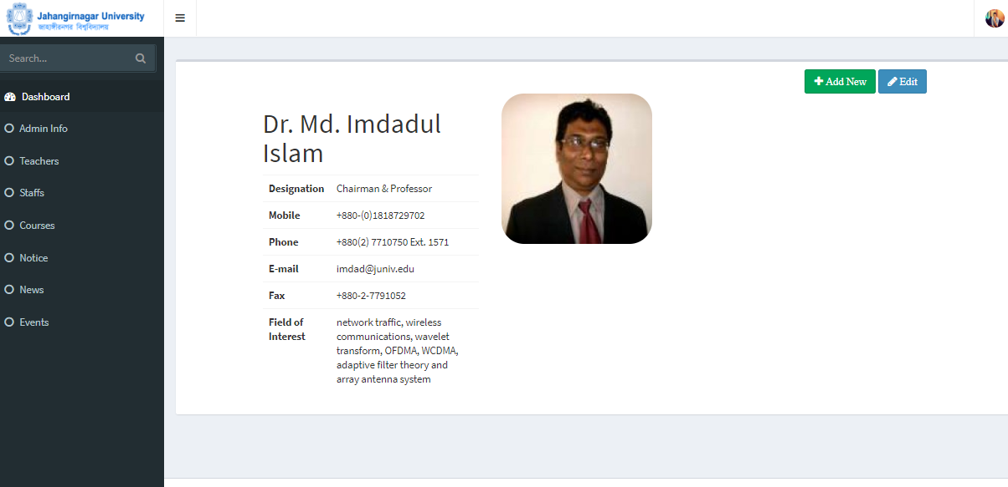

Figure 2.6: Admin Panel.

ADD COURSE

This page is developed for adding course for course module.

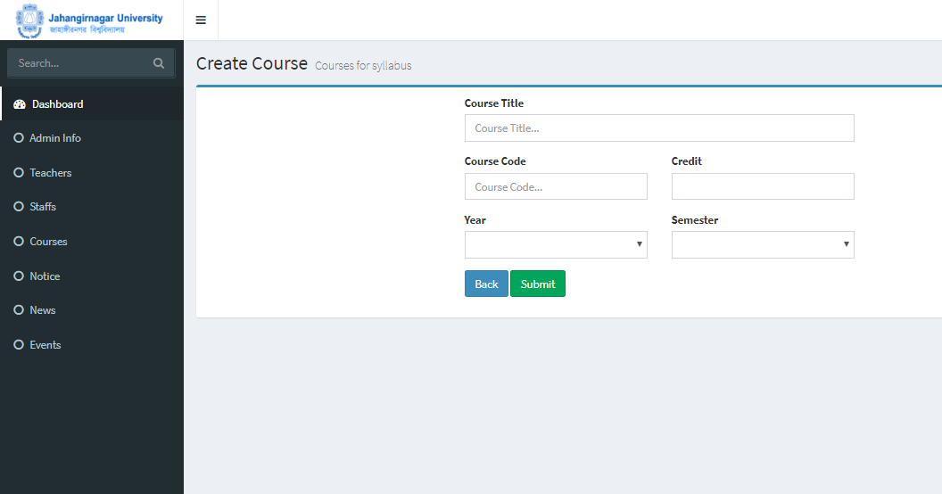

Figure 2.7: Add course page.

EDIT COURSE

This page is developed for editing course for course module.

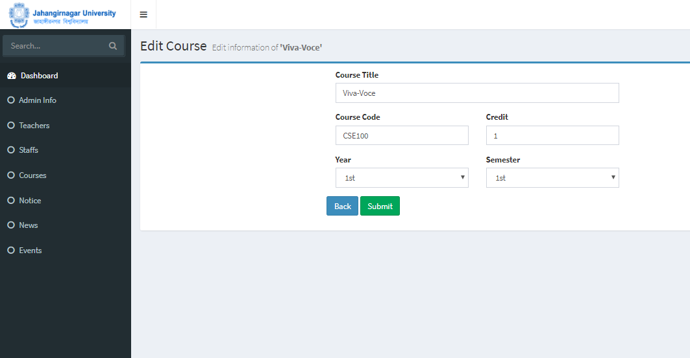

Figure 2.8: Edit course page.

SHOW COURSE LIST

This page is developed for showing course in course module.

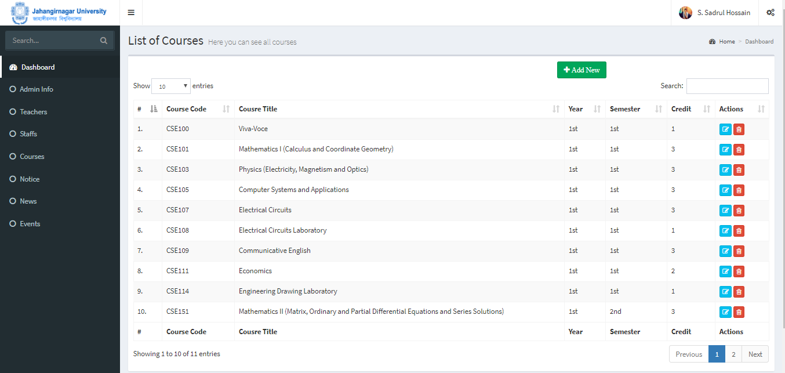

Figure 2.9: Show course list page.

ADD TEACHER

This page is developed for adding teacher for teacher module.

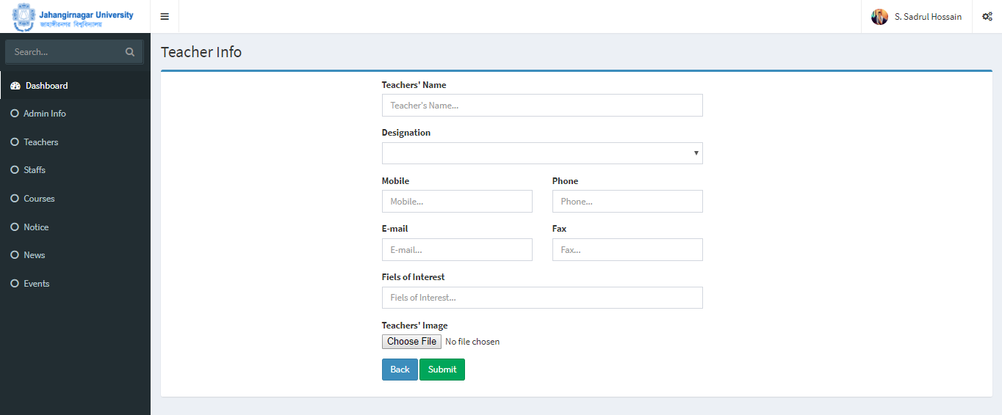

Figure 2.10: Add teacher page.

EDIT TEACHER

This page is developed for editing teacher for teacher module. 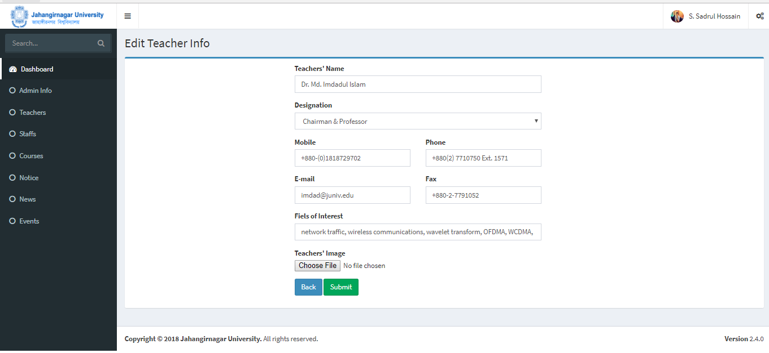

Figure 2.11: Edit teacher page.

SHOW TEACHER LIST

This page is developed for showing teacher list in teacher module.

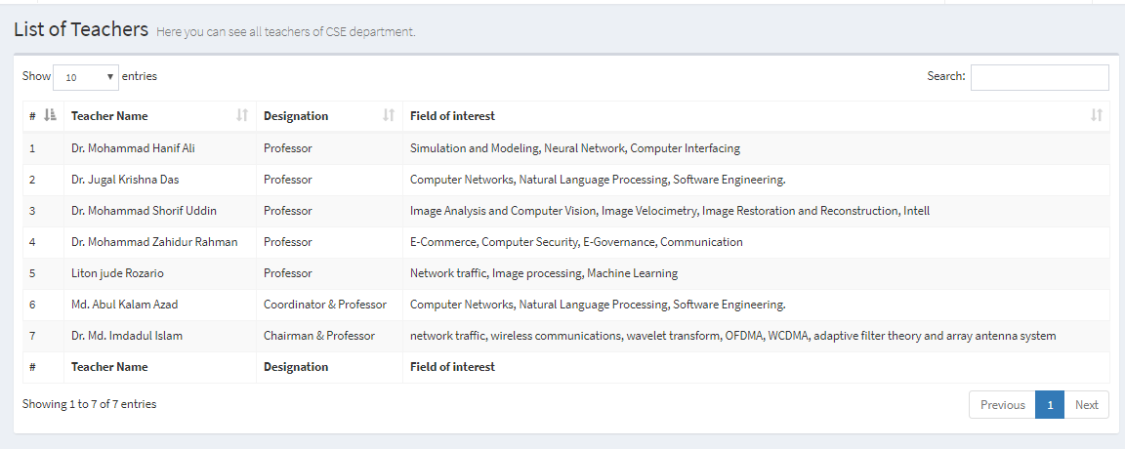

Figure 2.12: Show teacher list page.

**CHAPTER: 3**

**IMPLEMENTATION**

3.1 CONTROLLER

Controller is the part of a framework where blocks of code are written to control the flow of data. In this controllers are used to display pages, fetching and displaying data, inserting and editing, updating and deleting data.

INSERTION

For inserting data in database we need to declare from action route with ‘.store’. Then we need to write the following codes:

public function store(Request $request){

$this.validate($request, [

‘attributes’ => ‘validation_types’,

]);

$var = new table_name;

$var->attributes = $request->input_field_names;

$var->save();

return view(‘view_path’);

}

EDITION

For updating data we need to declare from action route with ‘.update’ with id. We need to write the codes same as insertion but with id of following row to be updated.

public function update(Request $request, $id){

$this.validate($request, [

‘attributes’ => ‘validation_types’,

]);

$var = table_name::find($id);

$var->attributes = $request->input_field_names;

$var->save();

return view(‘view_path’);

}

DISPLAY

To display a page, we need to declare view path in function.

public function function_name(){

return view(‘view_path’);

}

Data can be set with compact() function.

$var_name = sql query;

return view(‘view_path’, compact(‘var_name’));

DELETION

For deleting data we need to declare from action route with ‘.destroy with id. We need to write the codes same as insertion but with id of following row to be updated.

public function destory($id){

table_name::find($id)->delete();

return redirect()->back();

}

3.2 MODEL

Models are necessary to add functions to build relationship between tables and many other things. Database relationships such as ne to one, one to many, many to one and many to many are declared through the models.

3.3 ROUTE

Routes are necessary to choose how the url will be and which function controller will be visited for result. Routes are declared in many ways such as

with function Route::method_type(‘url’, function(){});

or with controller Route::method_type(‘url’, ‘controller_name@function_name’);

**CHAPTER: 4**

**TESTING & RESULT**

4.1 TESTING OF THE SYSTEM

Testing is a set of activity that can be planned in advance and conducted systematically. Developer of the software and an independent test group conducts testing. The software should be tested for expected result and efficiency after implementation of the system. Because during implementation everything may not be done according to the system design. So without testing those errors cannot be detected and then corrected. Therefore system testing is very important phase of a system development. Testing and debugging are different activities, but debugging must be accommodating in any testing strategy. Here we have discussed about different testing those we had conducted to make the system perfect. There are: [12]

4.2 UNIT TESTING

Unit testing focuses verification effort on the smallest unit of the system design the software component or module. All the inputs taken each module will be tested by testing data and different in results before and after adding validation will be shown. Different tests be conducted as part of unit testing are as follows:

1. Interface testing
2. Local data structure testing
3. Error handling paths testing
4. Boundary condition testing
5. Independent paths testing
6. Execution path testing

During the design of the system we had conducted these tests frequently. An example can be show of the result of a unit test for seeing whether it is fetching data from the database or not. The result by defining the variable in print_r() function.

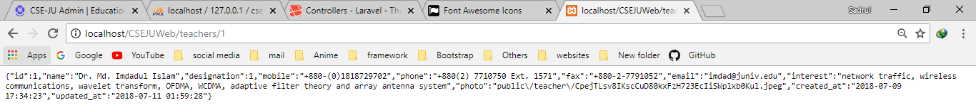

Figure 4.1: Result of a unit test.

4.3 INTEGRATION TESTING

Integration testing is a systematic technique for constructing the system architecture while at the same time conducting test to uncover errors associated with interface. The objective is to take unit tested component and build a program structure that has been dictated design.

Without email and password none can access the admin panel. All proposed modules checked whether data is fetched correctly or not. For example, syllabus can be found for all semesters.

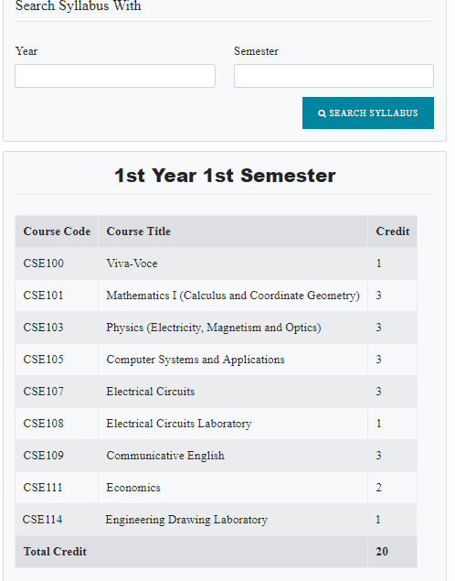

Figure 4.2: Result of an integrated test.

4.4 SYSTEM TESTING

System testing involves testing of the complete set of application program. This testing will be carried out to ensure that the program can be meet the demands of users. If would check the functionality of the proposed system. The test would pick the areas that need to be modified any omission or deficiencies in the way the system works. Algorithms are designed for the processes according to plan. Sometimes algorithms didn’t give expected result and failed while testing. We corrected the algorithms several times and tested the results. After few approaches, the test gave correct and expected results. In some portion, it gave expected result though the algorithm was not perfect. After several testes it shows up the flaws. By testing algorithms are being perfected and developed as the final absolute algorithm.

**CHAPTER: 5**

**CONCLUSION**

5.1 DISCUSSION

The website of CSE department developed in this project is very easy to operate for every user. The developed website fulfill our target with all the requirement. Though it fulfills all the related requirement, further we want to improve it, as it work more efficient and effective in future. The work as well as the technology is changing so rapidly that before we are being familiar with one technology another raises. There are some limitation in this system in which we have to work in future.

5.2 LIMITATION

This project has some limitations. The database has information of only one department. If there is any requirement of expanding the project to university level, then it will be required some modification and more information. Basically to get more data from all over the university and analyzing them needs time. So, time is a limitation here. Another limitation is budget. Budget will be needed to build this website more efficiently with more specifications and features.

5.3 FUTURE SCOPE

This project work can be developed in future with eliminating limitations and including more activities. Likewise, this website can be expanded to cover the entire university information. As it required more time and sound planning to gather data from all over the university. But it is very much possible to do so. So, we can hope for future enhancement and establishment of this website project.

**REFERENCES**

1. Introductory Process in Software Development, [Online Available form], <http://www.cbd-hq.com>, Visited Date: December 8, 2016.
2. SDLC, Roger S. Pressman, “Software Engineering” 6th Edition, pp. 368-411, 2005.
3. Elias, M. Awad, “System Analysis and Design”, 2nd Edition, pp. 45-51, 170-186, 335-336, 1997.
4. Shelly, G. B. and Rosenblatt, H. J., “Analyzing the Business Case” in “Systems Analysis and Design”, 8th Edition, Kathleen McMahon, Canada, PA: GEX Publishing Services, pp. 63-65, 2006.
5. R. T. Justis & B. Kreigsmann,. The feasibility study as a tool for venture analysis. Business Journal of Small Business Management 17 (1) 35-42, 1979.
6. J. A. O'Brien & G. M. Marakas, Developing Business/IT Solutions. In Management Information Systems, New York, NY: McGraw-Hill/Irwin, pp. 488-489, 2011.
7. Benjamin S. Blanchard & Wolt Fabrycky (uk).” Systems Engineering & Analysis”. 5th ed. (pp. 361).
8. Dave, W. Mercer et al, “BEGINNING PHP5” Edition, Chapter – I, pp. 12-23, 2004.
9. Shelly, G. B. and Rosenblatt, H. J., “Systems Design” in “Systems Analysis and Design”, 8th Edition, Kathleen McMahon, Canada, PA: GEX Publishing Services, pp. 402, 2006
10. A. Silberschatz, “Database System Concept”, 5th Edition, pp. 202-245, 2006.
11. Shelly, G. B. and Rosenblatt, H. J., “Systems Analysis” in “Systems Analysis and Design”, 8th Edition, Kathleen McMahon, Canada, PA: GEX Publishing Services, pp. 198, 2006.
12. William, E. Lewis, “Software Testing and Continues Quality Improvement”, CRC press, Chapter-9, pp. 56-78, 2000.